Maintaining different Releases in SVN

Introduction

This document gives the details of steps to be followed for maintaining different Releases in SVN. We will be use the concept of a “tag” to do this. Basically, a tag is just a “snapshot” of a project in time. In SVN, this idea already seems to be everywhere. Each repository version is exactly that – a snapshot of the file-system after each commit.

However, developers prefer to give more human-friendly names to tags, such as release-1.0. And they want to make snapshots of smaller subdirectories of the file-system. After all, it's not so easy to remember that release 1.0 of a piece of software is a particular subdirectory of revision so and so.

Steps to be followed for creating a Tag related to a Release

Whenever a Release is being created to be deployed on to the Test Servers in the TimesofMoney environment, we need to create a corresponding tag in the path https://192.168.1.67/svn/PayAgg/tags. Tags need to be created for UAT as well as production releases.

The tag name for UAT releases will be of the format “release-0.x.y.YYYYMMDD”. “x” will be incremented if this is a feature release and “y” will be incremented if it is a bug-fix release. “YYYYMMDD” represents current date. For Production releases later, we will use the general format “release-N.x.y.YYYYMMDD”, where “N” is an integer greater than 0.

- During the time the building of release or tagging is in progress, no changes must be checked in into the SVN repository. Otherwise, there may be a mismatch between the version used to build the Release and the one used for tagging.

- Build the Release with latest updates from the SVN. Verify that all the jar files and the EAR files for EJB and Web components are built properly.

- Deploy the newly built release onto the Test Servers and verify the basic functionality by doing a sanity test-run of the application.

- If the Release is found to be nor proper after the sanity testing in step 3, make necessary changes to fix issues found and repeat from step 1.

- If Release is found to be sane, create a tag with the tag-name as per the naming scheme. The command to be used is:

svn copy https://192.168.1.67/svn/PayAgg/trunk https://192.168.1.67/svn/PayAgg/tags/release-0.1.0.20130425
-m “Tagging the 0.1.0 release”

This will create a new revision in the repository.

It is possible to use UI provided by the option “Branch/Tag” in SVN Clients like TortoiseSVN (on Windows OS) and RabbitVCS (on Ubuntu) to do the tagging.

TortoiseSVN

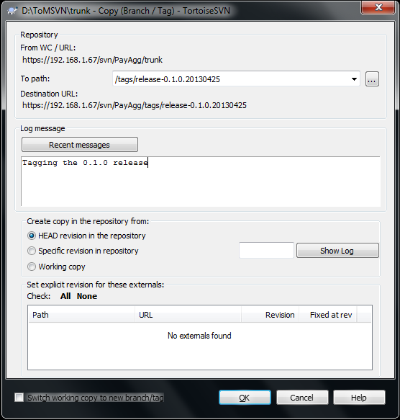

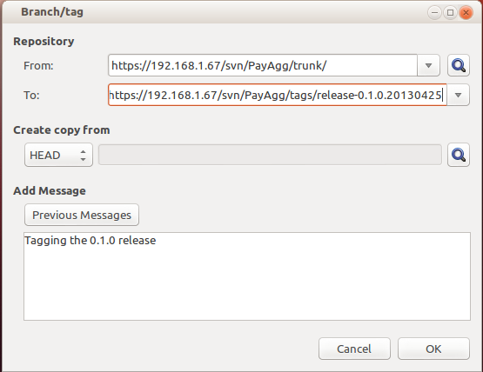
RabbitVCS

- After the tagging is complete, the developers may again start committing changes into SVN.

- Please ensure that no changes are done or committed into SVN in any of the files in the tags folder. The release folders that are created must always remain as snapshots. Normal development will go on in the trunk.

